**Von Neumann Computer**

**Computer parts**

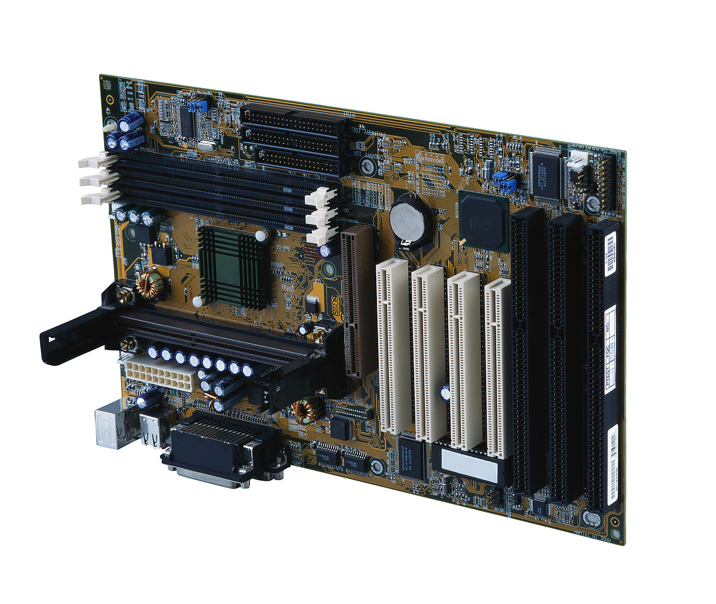

Name:

Material:

Purpose:

Circuits (electronic pathways) connect all components together

Components:

* Integrated circuits (flat rectangular boxes) for microprocessor ( ), Input, Output and memory

______________________________________________________________________________________

Name: Power Supply

Purpose:

Why:

*Primary Memory: Fast and relatively expensive; electronic (not mechanical)*

*Type 1:*

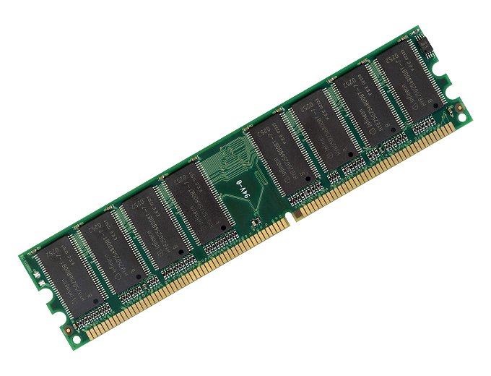

Name:

Purpose:

Appears as

Each location holds

* How much RAM is possible?
  1. The number of address lines determine the total amount of RAM possible
  2. If there are only 16 address lines, there can be only 216 addresses (64000 B)
  3. With 32 address lines, there can be 232 addresses (4 Gigabytes)
  4. With 64?

Is it volatile?

*Type 2:*

**CMOS** - needs little power--provided by a battery

* non-volatile
* stores data about the configuration of your machine
* can be changed by running a Setup program

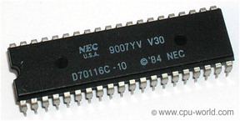

*Type 3:*

**ROM** - contains permanent instructions (BIOS) that execute when you turn on the computer

* non-volatile
* cannot be changed

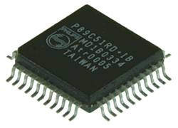

*Type 4:*

***Cache Memory -*** *high speed area where microprocessor places data that will probably be used*

* *volatile*

*Secondary Memory*

* Slower and cheaper; usually a mix of mechanical and electronic parts
* Purpose:

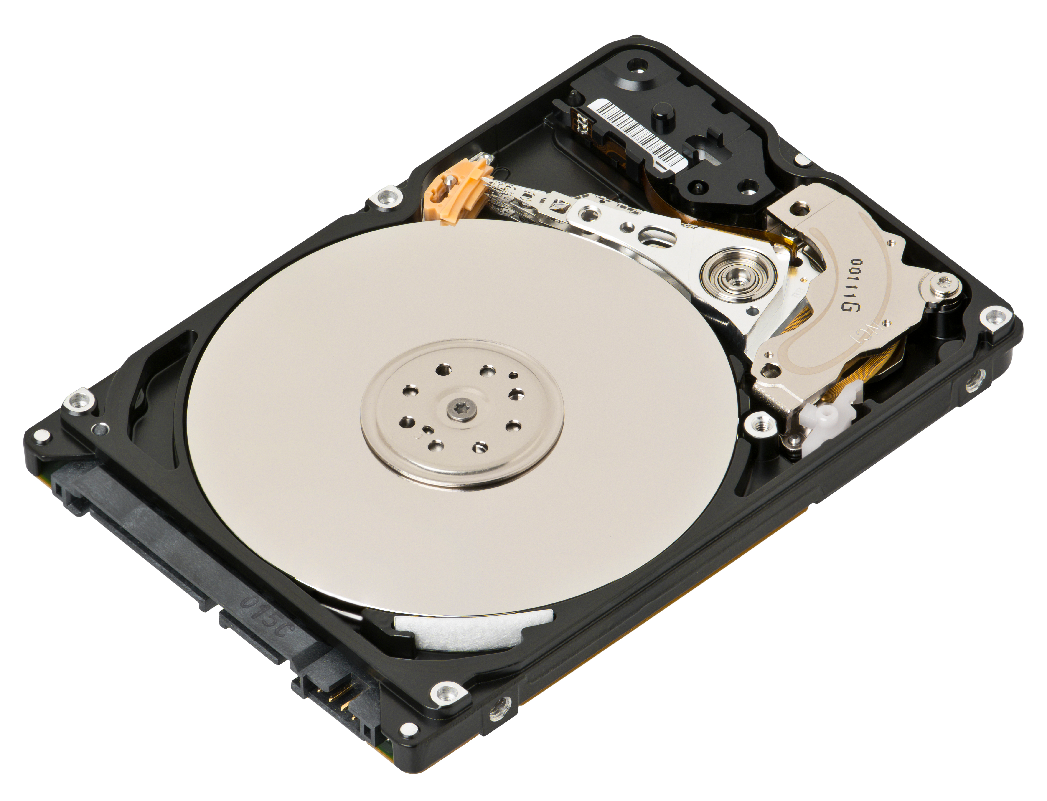

Name:

Type:

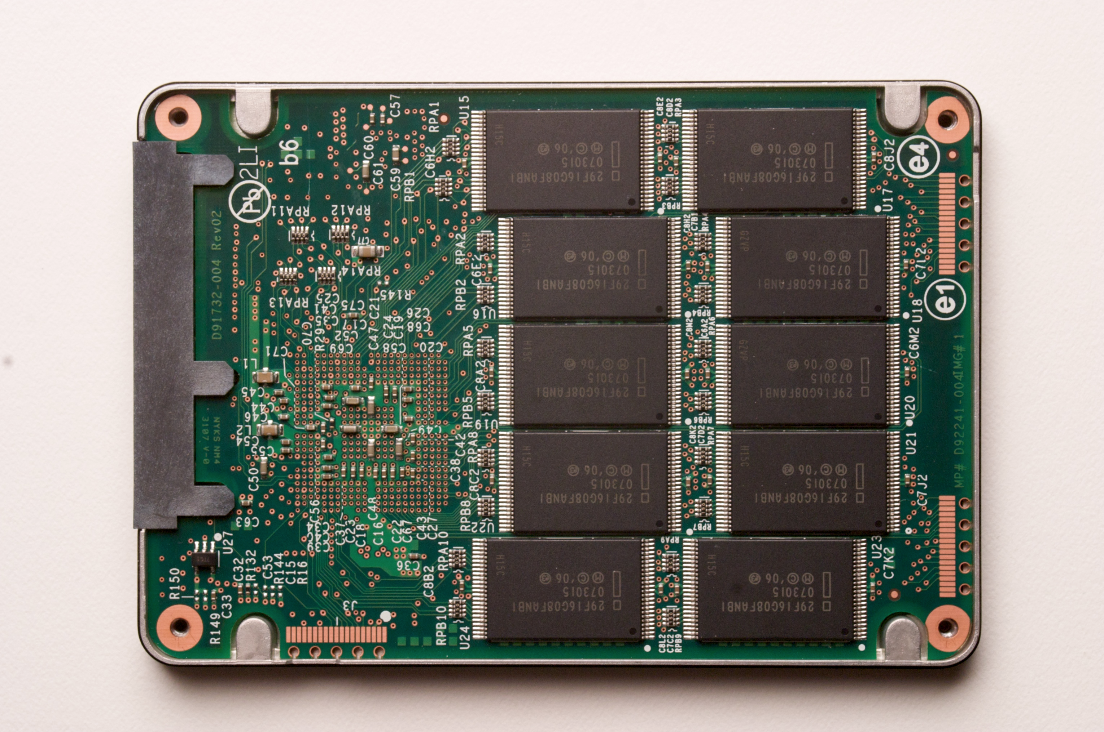

Name:

Type:

______________________________________________________________________________________

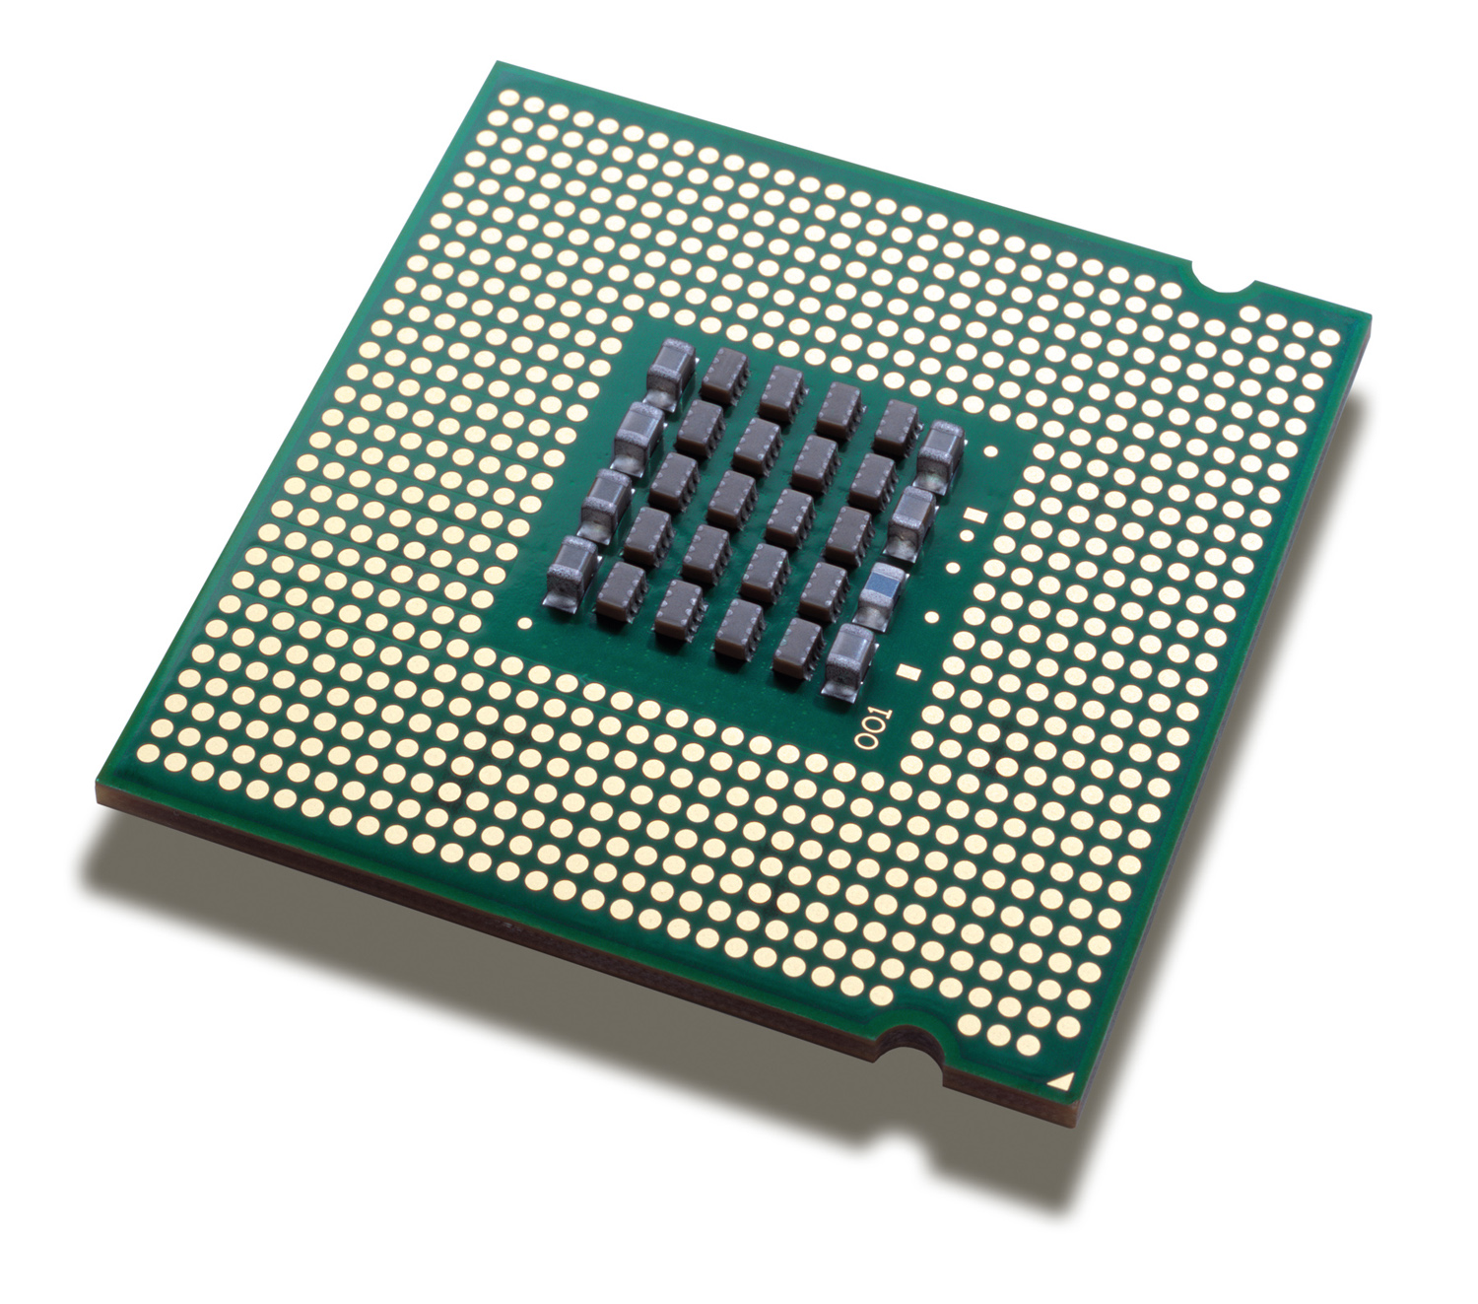

Name:

Purpose:

Examples: Intel 486, Pentium III, Pentium 4, Celeron, Intel 64, AMD64

It is a single chip containing

1.

2.

3.

It’s job:

* + Phase 1: get (*fetch)* the instruction from RAM and place in CU
  + Phase 2:  the instruction by moving data from RAM to registers in the ALU
  + Phase 3: execute instructions in the ALU
  + Phase 1 + Phase 2 + Phase 3 =

To measure speed:

* **MIPS** = million instructions per second

= clock rate x number of instructions per cycle

* **Throughput** = amount of data that can be processed per time unit (usually per second)

= MIPS x number of bytes processed per instruction

* *Suppose a CPU has a clock rate of 3 GHZ and can execute 2 instructions per clock cycle. How many instructions can it process per second? (express in MIPS)*
* *What is the throughput of that processor if each instruction processes 4 bytes per instruction?*

______________________________________________________________________________________

Input/Output Devices:

* each needs circuitry to control it

Examples:

______________________________________________________________________________________

*What happens when you turn on a PC?*

The Basic Input/Output System (**BIOS**) is software stored in flash memory (a BIOS chip) on your computer.

1. Turn it on: the BIOS software starts to execute.
2. BIOS checks the CMOS for custom settings
3. BIOS does a POST (Power up Self Test), checks graphics card
   * 1. RAM
     2. keyboard
     3. disk drives
4. BIOS Load the operating system (OS) from the hard drive
5. The OS takes over